Tim O’Brien Instagram NAMES:
BRINGING IT ALL TOGETHER: Now that you’ve looked at samples of Tim O’Brien’s recollections of war in two different genres, create an Instagram post from the perspective of Tim O’Brien to hype the episode containing the clip that we viewed. Use the template below to:
- create an avatar/symbol for O’Brien (not just a pic of him-paste the image over the black circle)
- Screencap an image from the video clip https://www.youtube.com/watch?v=FYckwwamKZs
- write a blurb from O’Brien’s POV
- create a hashtag
As you preview the episode in O’Brien’s words, be sure to capture his heart-truth: what he wants an audience to reconsider/know/understand about war, the people in it, and the effects. You will need 5-7 sentences with specific details from the story text and video clip. Email your Instagram to the teacher: cremar@cbsd.org

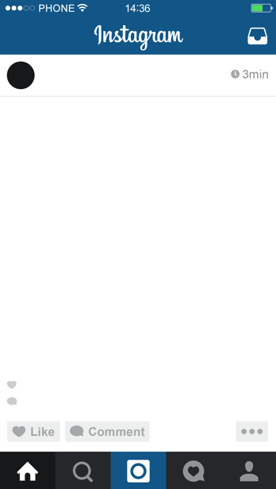
Create a hashtag here—still in O’Brien’s POV
Tim O’Brien
Texas

